CRUD

Using System.Data.SqlClient

Initialize()

{  
String constr = @”Data Source ”;

SqlConnection con = new sqlconnection(constr);

//reset

public void reset1()

{

name.Text = "";

age.Text = "";

address.Text = "";

cmb.SelectedIndex = -1;

sub.Text = "";

}

//data show in grid view

private void populate()

{

con.Open();

string Query = "select * from fill";

SqlDataAdapter sda = new SqlDataAdapter(Query, con);

var ds = new DataSet();

sda.Fill(ds);

dgv.DataSource = ds.Tables[0];

con.Close();

}

SqlConnection con = new SqlConnection(@"Data Source=(LocalDB)\MSSQLLocalDB;AttachDbFilename=F:\C#\WPF\WindowsFormsApp1\WindowsFormsApp1\Curd.mdf;Integrated Security=True");

private void reset_Click(object sender, EventArgs e)

{

reset1();

}

//Insert Code

private void add_Click(object sender, EventArgs e)

{

string query = "Insert into fill values('" + name.Text + "', '" + age.Text + "', '" + address.Text + "', '" + cmb.SelectedItem.ToString() + "', '" + sub.Text + "')";

con.Open();

SqlCommand cmd = new SqlCommand(query, con);

cmd.ExecuteNonQuery();

MessageBox.Show("Insert");

con.Close();

reset1();

populate();

}

//view data

private void view_Click(object sender, EventArgs e)

{

populate();

}

//update

private void update_Click(object sender, EventArgs e)

{

string query = "Update fill set name='" + name.Text + "',age='" + age.Text + "',gender='" + cmb.SelectedItem.ToString() + "',address='" + address.Text + "', subject='" + sub.Text + "' where id=" + key + ";";

con.Open();

SqlCommand cmd = new SqlCommand(query, con);

cmd.ExecuteNonQuery();

MessageBox.Show("update");

con.Close();

reset1();

populate();

}

//selected data in form

//gridview -> events -> cellclick

int key = 0;

private void dgv_CellClick(object sender, DataGridViewCellEventArgs e)

{

DataGridViewRow dgvRow = dgv.Rows[e.RowIndex];

name.Text = dgvRow.Cells[1].Value.ToString();

age.Text = dgvRow.Cells[2].Value.ToString();

address.Text = dgvRow.Cells[3].Value.ToString();

cmb.SelectedItem = dgvRow.Cells[4].Value.ToString();

sub.Text = dgvRow.Cells[5].Value.ToString();

if (name.Text == "")

{

key = 0;

}

else

{

key = Convert.ToInt32(dgvRow.Cells[0].Value.ToString());

}

}

private void delete_Click(object sender, EventArgs e)

{

string query = "Delete from fill where id=" + key + "";

con.Open();

SqlCommand cmd = new SqlCommand(query, con);

cmd.ExecuteNonQuery();

MessageBox.Show("Delete");

con.Close();

reset1();

populate();

}

WPF

Stack panel

<StackPanel Orientation = "Horizontal">  
         <Button x:Name = "button" Content = "Button" Margin = "10" Width = "120" Height = "30" />  
         <Button x:Name = "button1" Content = "Button" Margin = "10" Width = "120" Height = "30" />  
         <Button x:Name = "button2" Content = "Button" Margin = "10" Width = "120" Height = "30" />  
         <Button x:Name = "button3" Content = "Button" Margin = "10" Width = "120" Height = "30" />  
      </StackPanel>

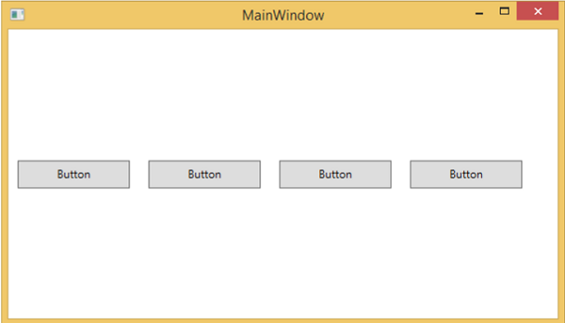

Wrap panel

<WrapPanel Orientation = "Vertical">  
         <TextBlock Text = "Fist Name" Width = "60" Height = "20" Margin = "5" />  
         <TextBox  Width = "200" Height = "20" Margin = "5" />  
         <TextBlock Text = "Last Name" Width = "60" Height = "20" Margin = "5" />  
         <TextBox  Width = "200" Height = "20" Margin = "5"/>  
         <TextBlock Text = "Age" Width = "60" Height = "20" Margin = "5" />  
         <TextBox  Width = "60" Height = "20" Margin = "5" />  
         <TextBlock Text = "Title" Width = "60" Height = "20" Margin = "5" />  
         <TextBox  Width = "200" Height = "20" Margin = "5" />  
      </WrapPanel>

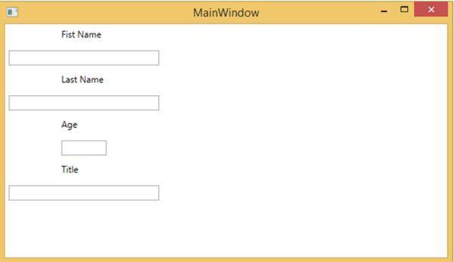

Dock Panel

DockPanel LastChildFill = "True">  
         <Button Content = "Top" DockPanel.Dock = "Top" Click = "Click_Me" />  
         <Button Content = "Bottom" DockPanel.Dock = "Bottom" Click = "Click_Me" />  
         <Button Content = "Left" Click = "Click_Me" />  
         <Button Content = "Right" DockPanel.Dock = "Right" Click = "Click_Me" />  
         <Button Content = "Center" Click = "Click_Me" />  
      </DockPanel>

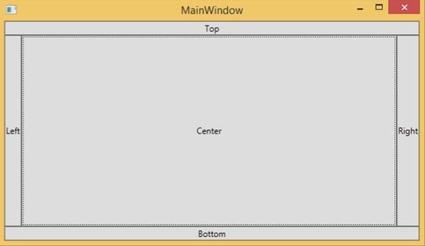

Canvas panel

<Canvas Width = "580" Height = "360" >  
         <Ellipse Canvas.Left = "30" Canvas.Top = "30"    
            Fill = "Gray" Width = "200" Height = "120" />  
         <Ellipse Canvas.Right = "30" Canvas.Top = "30"    
            Fill = "Aqua" Width = "200" Height = "120" />  
         <Ellipse Canvas.Left = "30" Canvas.Bottom = "30"    
            Fill = "Gainsboro" Width = "200" Height = "120" />  
         <Ellipse Canvas.Right = "30" Canvas.Bottom = "30"    
            Fill = "LightCyan" Width = "200" Height = "120" />  
      </Canvas>

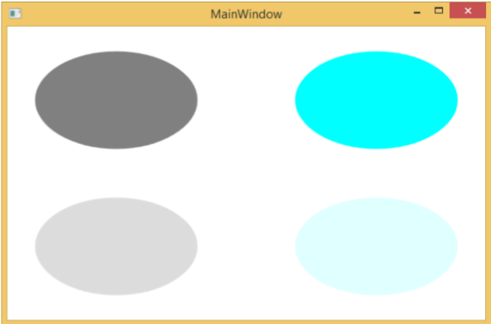

Grid panle

<Grid x:Name = "FormLayoutGrid" Background = "AliceBlue">  
      <Grid.ColumnDefinitions>  
         <ColumnDefinition Width = "Auto" />  
         <ColumnDefinition />  
      </Grid.ColumnDefinitions>  
        
      <Grid.RowDefinitions>  
         <RowDefinition Height = "*" />  
         <RowDefinition Height = "*" />  
         <RowDefinition Height = "*" />  
      </Grid.RowDefinitions>  
        
      <TextBlock Grid.Row = "0" Grid.Column = "0" Text = "Name" Margin = "10"    
         HorizontalAlignment = "Left" VerticalAlignment = "Center" Width = "100" />  
      <TextBox Grid.Row = "0" Grid.Column = "1" Margin = "10" />  
      <TextBlock Grid.Row = "1" Grid.Column = "0" Text = "ID" Margin = "10"    
         HorizontalAlignment = "Left" VerticalAlignment = "Center" Width = "100" />  
      <TextBox Grid.Row = "1" Grid.Column = "1" Margin = "10" />  
      <TextBlock Grid.Row = "2" Grid.Column = "0" Text = "Age" Margin = "10"    
         HorizontalAlignment = "Left" VerticalAlignment = "Center" Width = "100" />  
      <TextBox Grid.Row = "2" Grid.Column = "1" Margin = "10" />  
   </Grid>

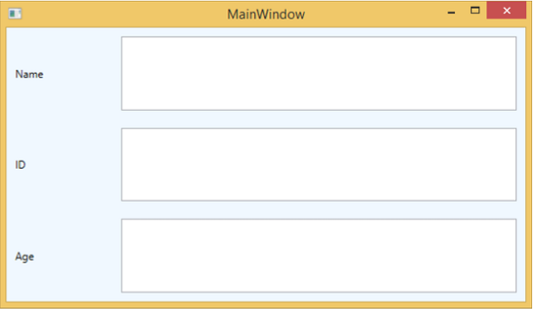

take one text box name is txtEx

take openfile dialog

OpenFileDialog ofd = new OpenFileDialog();

ofd.Title = "Open a Text File";

ofd.Filter = "Text Files (*.txt) | *.txt | All Files(*.*) | *.*"; //Here you can filter which all files you wanted allow to open

DialogResult dr = ofd.ShowDialog();

if (dr == DialogResult.OK) {

StreamReader sr = new StreamReader(ofd.FileName);

txtEx.Text = sr.ReadToEnd();

sr.Close();

}

take one text box name is txtEx

take savefile dialog

SaveFileDialog sfdlg = new SaveFileDialog();

sfdlg.Filter = "Text Files (*.txt) | *.txt"; //Here you can filter which all files you wanted allow to open

if (sfdlg.ShowDialog() == DialogResult.OK) {

// Code to write the stream goes here.

}

take one text box name is txtEx

take color dialog

//Color Dialog

ColorDialog cdlg = new ColorDialog();

cdlg.ShowDialog();

txtEx.ForeColor = cdlg.color;

take one text box name is txtEx

take font dialog

//Font Dialog

FontDialog fdlg = new FontDialog();

fdlg.ShowDialog();

txtEx.Font = fdlg.Font;

User Control

Add newFolder(UserControl) 🡪 Add User Control(Name of user control) 🡪